Labview를 이용한 Data Acquisiton
차례
Transducer, Signals, and Signals Conditioning
DAQ Hardware and Software
Analog Input
Analog Output
Digital I/O
Counters

Transducer, Signals, and Signals Conditioning
Transducer란 무엇인가?
Transducer의 종류
http://www.ni.com/sensors/toc.htm
분류 : Analog - Level, shape, frequency
Digital - state, rate

Signal Conditioning
http://www.ni.com/sigcon/tutorial.htm

Amplification
노이즈의 크기를 최소화하기 위해서는 증폭기를 신호소스 가까운 곳에 달아야 된다.

Singal to Noise Ratio
Table(pp. 1-22)

Signal conditioning의 몇 가지 형태
- Transducer Excitation
- Linearization
- Isolation
- Filtering

일반적인 signal conditioning 형태

DAQ Hardware and Software
Terminal block and cable, http://www.ni.com/catalog/

Components of DAQ Device
- I/O Connector
- Computer I/O interface circuitry
- Real-Time System(여러 보드를 사용할 때 연결)
- Analog input circuitry
  - ADC
  - Multiplexer
  - Instrumentation Amplifier
- Analog output circuitry
- Digital I/O
- Counter circuitry

Configuration Considerations
- Analog input
  - Resolution
  - Range
  - Gain
  - Code width
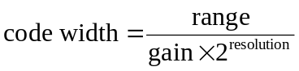
  - Mode : differential, referenced single-ended, non-referenced single-ended
위 모드는 시스템부와 PC부에서 각기 정의된다.
즉
- System이 grounded된 출력을 가질 때
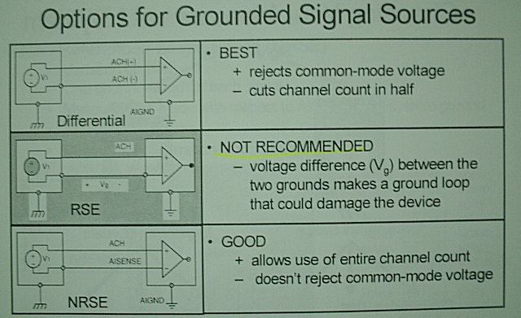
얻고자 하는 신호가 grounded된 신호라면, Differential mode로 DAQ에서 얻는 것이 가장 좋은 성능을 보이고 다음으로 NRSE이다. 이때 주의할 것은 RSE mode로 해서는 안된다는 것이다. 왜냐하면 ground loop가 형성되어 노이즈의 원인이 되기 때문이다.
일반적인 생체 신호 앰프를 거친 신호를 컴퓨터로 얻고자 할 때는 ground된 시스템이므로 differential mode로 얻는 것이 좋다. 하지만 이때 전체 채널수가 반으로 줄어드는 단점이 있다.
- System이 floating된 출력을 가질 때
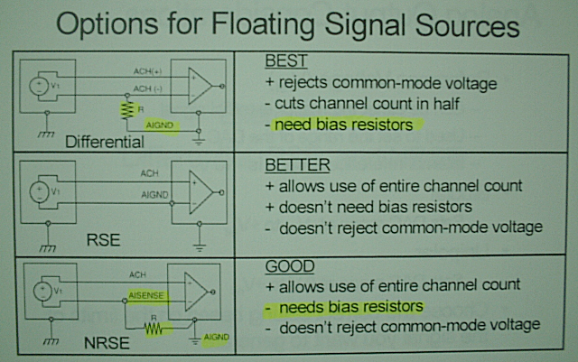
얻고자 하는 신호가 Floating된 신호라면, 어떤 mode로 DAQ에서 데이터를 받아도 크게 상관은 없으나 Differential mode가 최고이다. 그러나 이때 반드시 bias resistor를 부착하여 ground를 형성해 주는 것이 좋다. 다음으로 RSE, NRSE이다.

Grounding Issues
Bias Resistors
pp. 2-32, 2-35
- Analog output
  - Internal vs. external reference voltage
  - Bipolar vs. unipolar
- Digital I/O
- Counters

DAQ software
Max – virtual channel(ex, 2-4), scaling

Analog Input
Consideration
Frequency
Alias frequency = | N * sampling frequency – actual signal frequency|
Preventing Aliasing : oversampling, filtering

DAQ Acquisition Palette
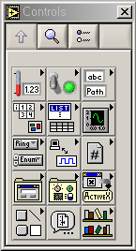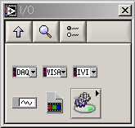
DAQ Channel Name Data Type
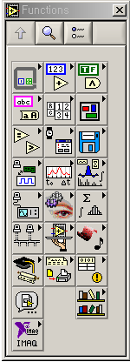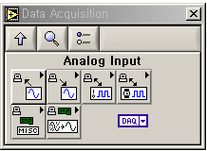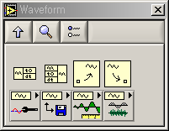

DAQ Device Architectures (pp.3-27)
Sampling Terminology
- Scan : 여러분이 지정한 모든 채널에 대하여 하나의 샘플을 얻는 것
- Scan rate : 초당 scan하는 수(scan/sec)
- Scan clock(=Scan interval) = Scan clock period = 1/scan rate = sampling rate
- Channel clock(=interchannel delay)
- Scan Duration : 한번 scan할 때 걸리는 시간 = (채널수-1) * interchannel delay

Sampling methods
- Interval sampling
- Round-Robin Sampling
- Simultaneous Sampling
Buffersize
Scan Backlog
Overwrite Error
Overflow Error

Single-point Acquisition
Buffered Acquisition, pp.3-41,42
Continuous Acquisition, pp.3-48, 49, 50
Triggered Acquisition
모든 보드가 triggering을 지원하는 것은 아니다.
Mode
Digital Triggered Acquisition
Analog Triggered Acquisition
Conditional Retrieval
Reference
- NI-DAQ Function Reference Online Help
- NI-DAQ User Manual
Analog Output
pp.4-14, 15

Continuous Generation Flowchart
pp.4-19, 20

Digital I/O
Terminology
Bit
Line
Port
Port Width
Mask

CIN
Code Interface Node (CIN)
CIN Example with LabVIEW and MS Visual C++ 5.0
In this example you will create a CIN that takes in two numbers, multiplies them together and outputs the result ( A*B = C ). The code that will be loaded in the CIN will be generated with MS Visual C++ 5.0 in the Integrated Development Environment ( IDE ).
- In LabVIEW, open a new VI and save it as "Mult.vi"
- On the front panel, place two numeric controls to use as inputs and a numeric indicator to use as an output. Name them A, B and C respectively. In this example we set the numeric representation to single precision by popping up ( right clicking ) on all three and selecting Representation>>SGL.
Front Panel | Block Diagram
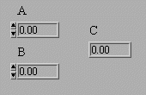 | 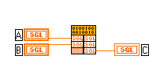
- On the block diagram, resize the CIN so that it has three parameter boxes.
Wire up the two inputs on the left.
Wire the output on the right, pop up on the parameter box and select "Output Only."
Then pop up on the top part of the CIN and choose "Create .c File...."
This will create a "Mult.c" file, which will be used later.
- Open MS Visual C++, and perform the following steps.
a) Create a DLL project.
Make a new project by opening File>>New...
Name the project "Mult"
Select the type to be "Win32 Dynamic-Link Library." and click OK.
b) Add CIN objects and libraries to the project.
Select Project>>Add To Project>>Files...
Then go to the Win32 subdirectory of your cintools directory and select:
cin.obj, labview.lib, lvsb.lib, and lvsbmain.def
You can select multiple items by holding down the "control" button and clicking on the items you want. Then click OK.
c) Add your "Mult.c" file to the project.
Select Project>>Add To Project>>Files...
Then go to the folder that holds your "Mult.c" file and select it. Then click OK.
d) Edit Project Settings.
Open Project>>Settings...
Set the "Settings For:" field to be "All Configurations"
The remaining sub-steps are all within this panel.
Do not click the OK button, until instructed to do so later.
(1) On the "C/C++" tab.
    - Set the "Category:" field to "Preprocessor".
-Add the absolute path to your cintools directory in the "Additional include directories" field. Paths are in MS-DOS Format.
-- We used --
C:\Progra~1\Nation~1\LabVIEW\Cintools

    - Set the "Category:" field to "Code Generation".
-Change the "Use run-time library" field to "Multithreaded DLL".
-Change the "Struct member alignment" field to "1 Byte".
(2) On the "Custom Build" tab, scroll right to get the tab.
    - Fill in the fields:
Build command:
<your Cintools path>\win32\lvsbutil $(TargetName) -d "$(WkspDir)\$(OutDir)"
-- We used --
C:\Progra~1\Nation~1\LabVIEW\Cintools\win32\lvsbutil $(TargetName) -d "$(WkspDir)\$(OutDir)"
Output files:
$(OutDir)$(TargetName).lsb
(3) Click OK
e) Add the code to "Mult.c"
Select the "File View" tab in the Work Space Window. Double click on "Mult.c"
Type the following in the area that says /*ENTER YOUR CODE HERE*/:
*C = *A * *B;
Verify that your code compiles by selecting Build>>Compile Mult.c
If the code does not compile, debug your code before continuing.
f) Generate the Code Resource File.
Select Build>>Build Mult.dll
This will create the "Mult.lsb" file that will be loaded into your CIN.
- In LabVIEW, pop-up on the top section of the CIN in your block diagram and choose "Load Code Resource..." Choose the "Mult.lsb" file from the folder:
Program Files\DevStudio\MyProject\Mult\Debug
You should get a white run arrow and be able to execute "Mult.vi".
Source http://www.ni.com/support/labview/program/callcode/cinex.htm

